

Semester One Examination, 2021

Question/Answer booklet

MATHEMATICS SPECIALIST
UNIT 3

Section One:

Calculator-free

Your Name

Your Teacher’s Name

Time allowed for this section
Reading time before commencing work: five minutes
Working time: fifty minutes

Materials required/recommended for this section
To be provided by the supervisor
This Question/Answer booklet
Formula sheet

To be provided by the candidate
Standard items: pens (blue/black preferred), pencils (including coloured), sharpener, correction fluid/tape, eraser, ruler, highlighters

Special items: nil

Important note to candidates
No other items may be taken into the examination room. It is your responsibility to ensure that you do not have any unauthorised material. If you have any unauthorised material with you, hand it to the supervisor before reading any further.
Question | Mark | Max | Question | Mark | Max
1 |  |  | 5
2 |  |  | 6
3 |  |  | 7
4 |  |  | 8

Structure of this paper

Section | Number of questions available | Number of questions to be answered | Working time (minutes) | Marks available | Percentage of examination
Section One:  Calculator-free | 8 | 8 | 50 | 50 | 36
Section Two:  Calculator-assumed | 14 | 14 | 100 | 96 | 64
 |  |  |  | Total | 100

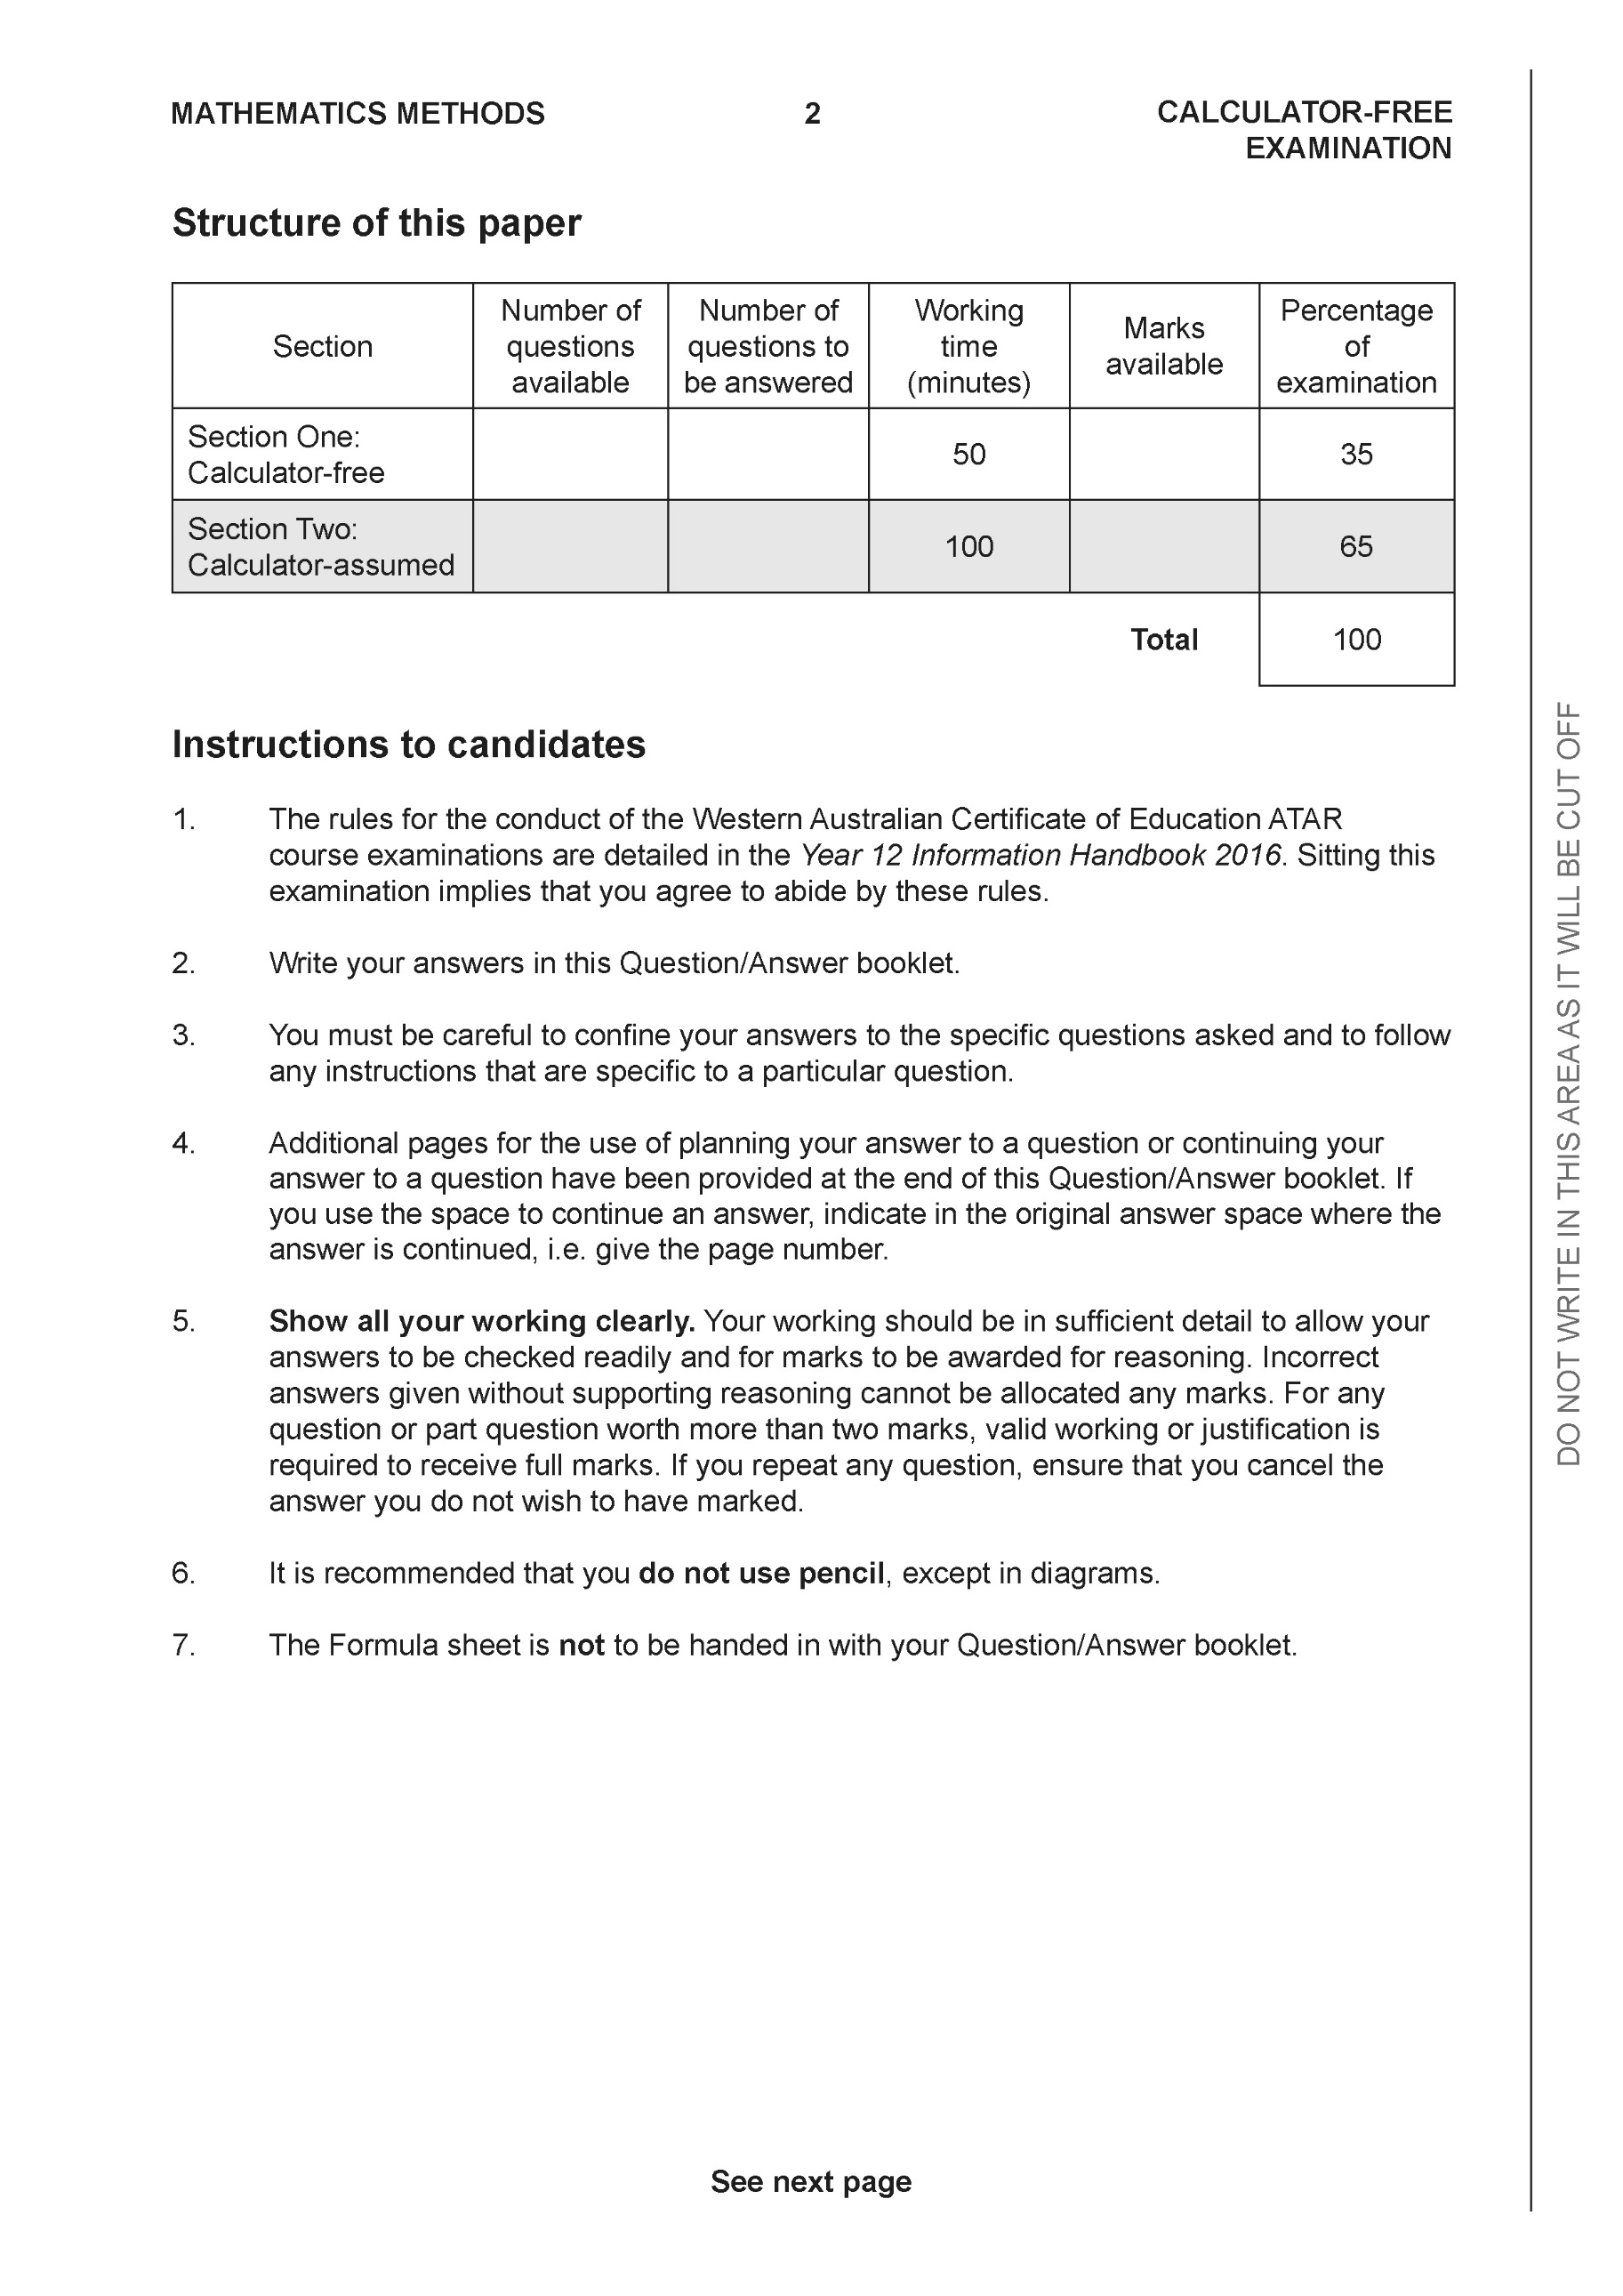

Section One: Calculator-free (50 Marks)

This section has eight (8) questions. Answer all questions. Write your answers in the spaces provided.

Spare pages are included at the end of this booklet. They can be used for planning your responses and/or as additional space if required to continue an answer.
● Planning: If you use the spare pages for planning, indicate this clearly at the top of the page.
● Continuing an answer: If you need to use the space to continue an answer, indicate in the original answer space where the answer is continued, i.e. give the page number. Fill in the number of the question that you are continuing to answer at the top of the page.

Working time: 50 minutes.

Question 1 (6 marks)

Consider the plane which contains point A

(a) Write a vector equation for this plane. (3 marks)

Consider the line
(b) Determine the coordinates of where the line above meets the plane. (3 marks)

Question 2 (6 marks)

Sketch the graph where . Clearly show the major features of the graph.

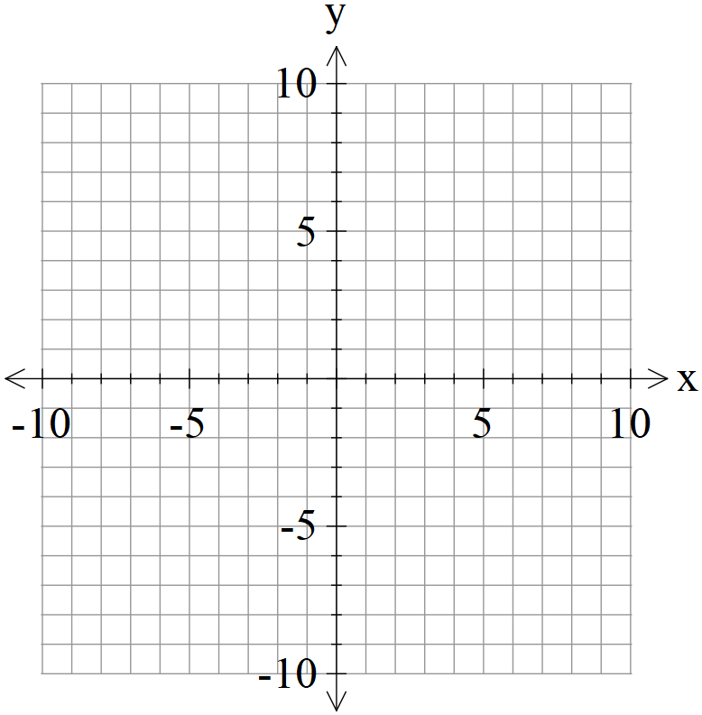

Question 3 (6 marks)

Consider the plane that contains the following three points . Using vector methods, determine the distance of point from the plane . Show all working and reasoning.

Question 4 (5 marks)

Consider the function as graphed below.
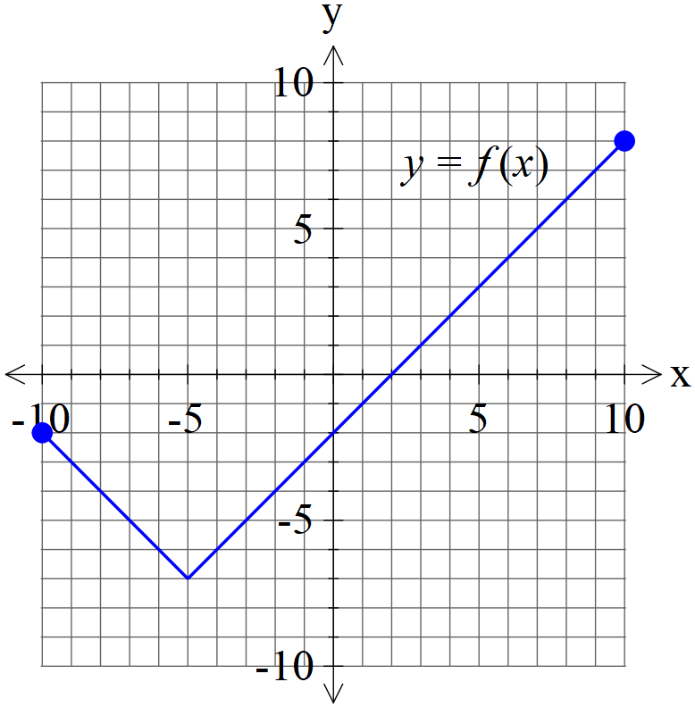
- Graph on the axes below. (2 marks)
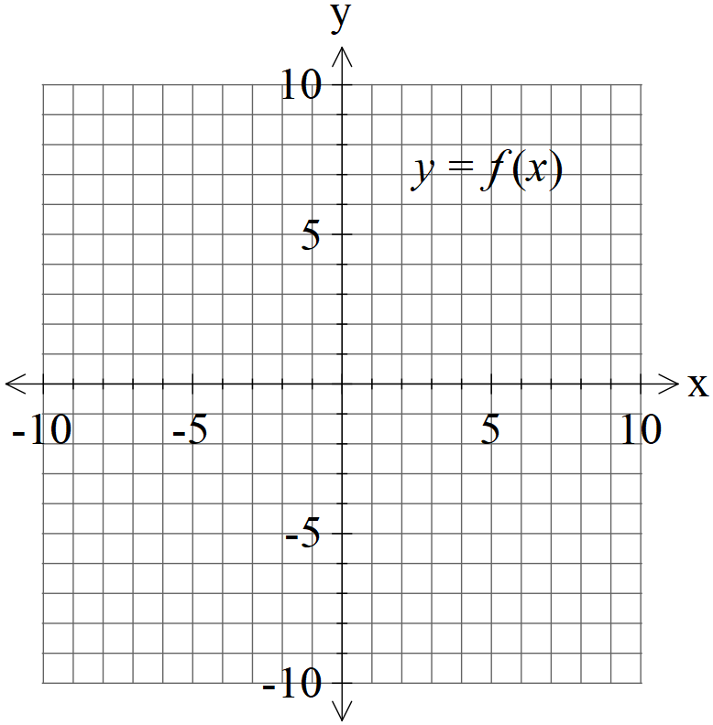
- Graph on the axes below. (3 marks)


Question 5 (7 marks)

Consider the function with domain

(a) Determine and its domain. (4 marks)

(b) Consider with and real constants. Given that has an inverse which intersects graphically with at one point only, determine a possible exact value for in terms of and an equation that must satisfy.
(3 marks)

Question 6 (7 marks)

Consider the following system of linear equations.

- Solve for . (3 marks)

Q6 cont-

- If we modify the equations to the following with being constants, solve for the following values of such that there are:
- no solutions
- infinite solutions (Give a geometrical interpretation of this situation) (4 marks)

Question 7 (10 marks)

- Solve for all solutions to the following in the form with .
(4 marks)

- Plot the above roots on the diagram below, indicating scale. (3 marks)

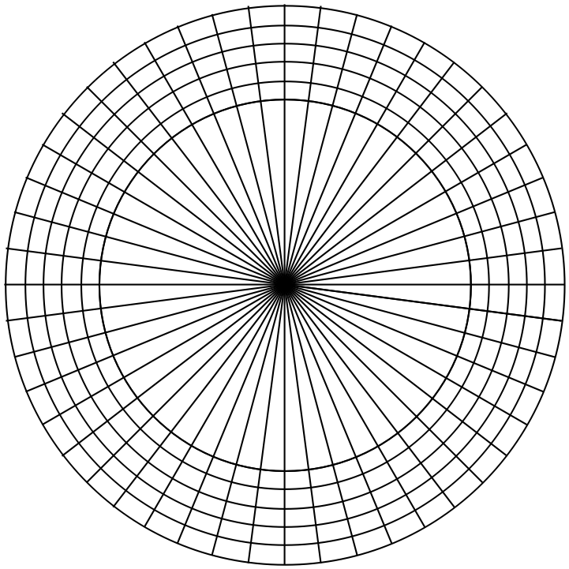

- If these points are joined, forming a polygon, determine the exact area of this polygon.
(3 marks)

Question 8 (3 marks)

Sketch the locus of points that satisfy on the complex plane below and explain your reasoning.

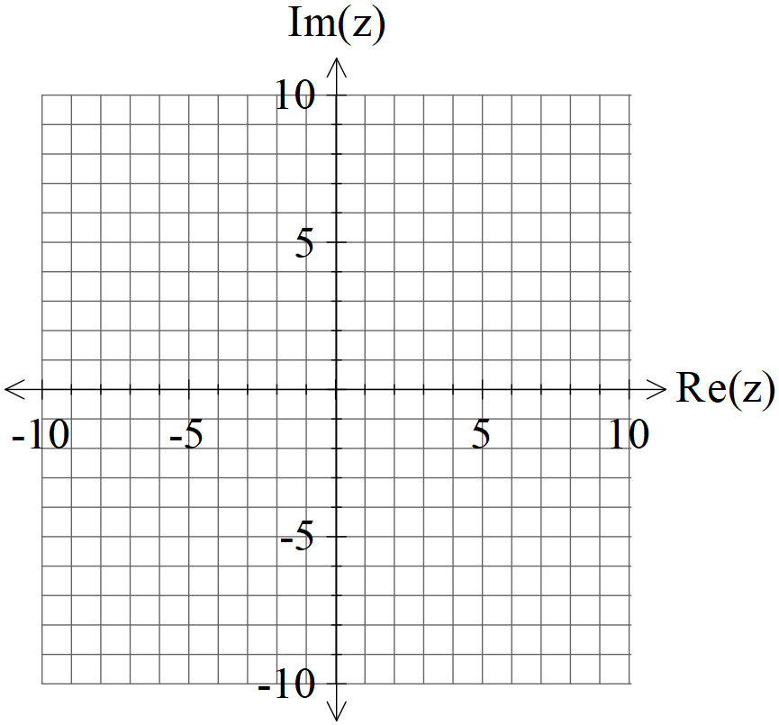
Additional working space
Question number:

Additional working space
Question number:

Additional working space
Question number:

Acknowledgements

